Top of Form
8/14 Adrian Douglas - THE VANISHING METALS

THE VANISHING METALS

Adrian Douglas
There has been much talk in the press that the culprits for driving up the price of metals and, in fact, commodities in general, are the Hedge Funds. These same reports warn investors about investing in commodities because they argue that when the Hedge Funds move out of commodities into the next hot sector the commodity prices will collapse. A review of metals prices and warehouse levels show such arguments are false. Hedge funds do not take delivery of metals. Their purchases remain on the exchange in the “eligible” category which is counted as warehouse inventory along with the dealer inventory (“registered’ category). I have made a compilation of base metal prices over the last five years along with the warehouse inventory levels courtesy of Kitco (www.kitcometals.com). What is clear is that the rising prices are accompanied in general with dramatically reducing inventory. Therefore, it can be concluded that REAL demand and REAL consumption is the main driver of the price of base metals not the speculation of the Hedge Funds.
Copper
Copper has seen a drawdown of inventory of almost 90% in the last four years!
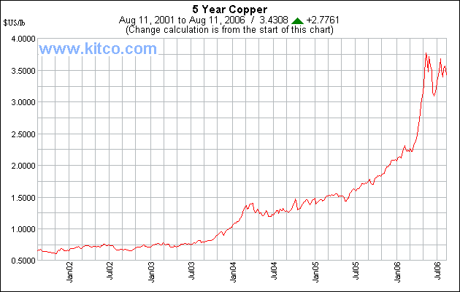
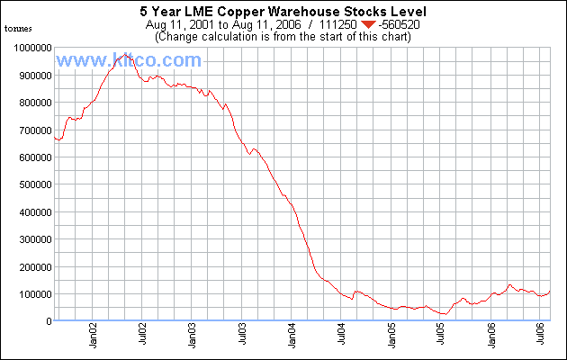
Aluminum
Aluminum has seen a drawdown of inventory of almost 50% from its recent peak.
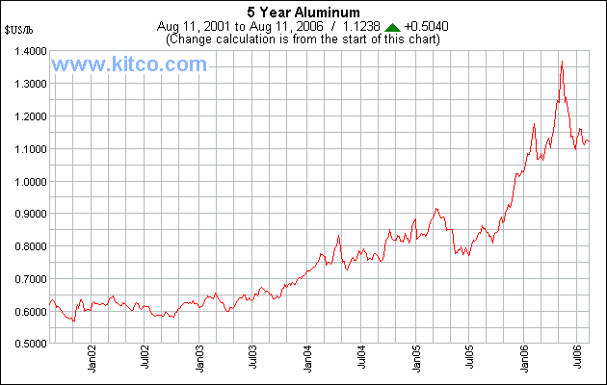
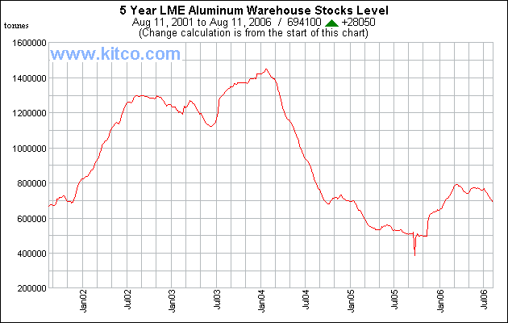
Lead
Lead has seen a drawdown of inventory of almost 55% from its peak level.
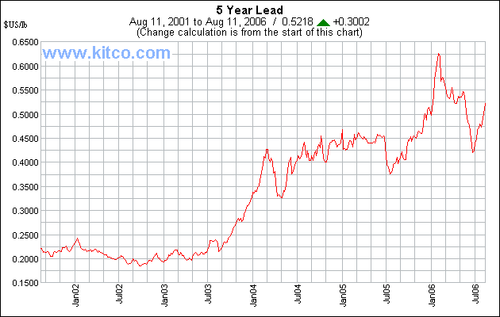
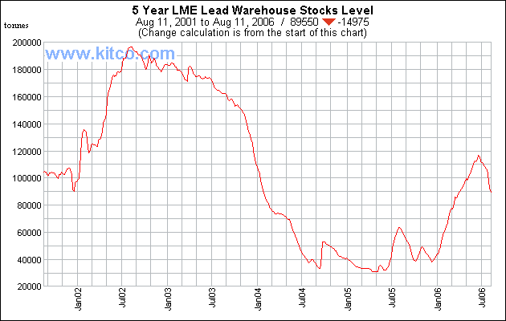
Nickel
Nickel has seen a drawdown of inventory of almost 80% from its recent peak of 36,000 tonnes. The latter half of 2005 saw a huge stock build up of Nickel on the LME but the drawdown of that inventory has been just as fast!
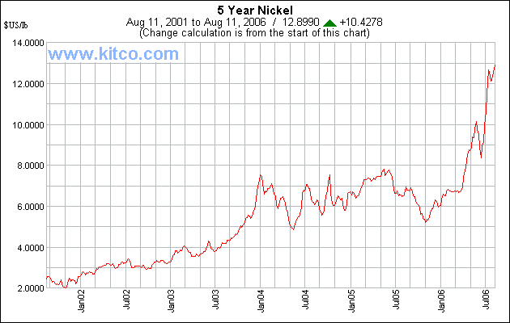
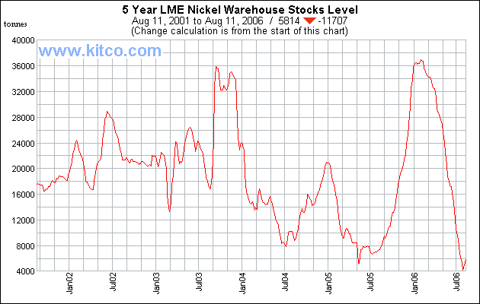
Zinc
Zinc has seen a drawdown of inventory of almost 80% from its recent peak level!
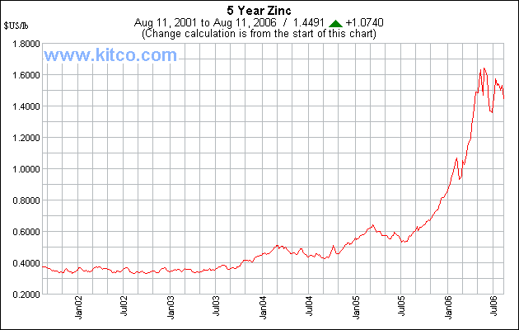
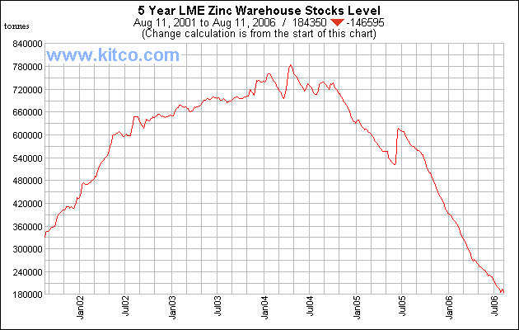
Silver
I have only accumulated data for silver for the last 9 months but it can be seen that a similar trend in price and inventory exists. Silver inventory has fallen 22% in the last 6 months. Silver is a precious metal but it has a strong link to base metals because most silver mine production comes as a by-product of zinc and lead mining.
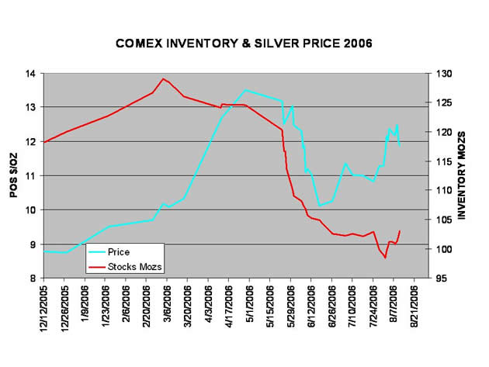
It is clear that the commodity bull is being driven by physical markets. Entities who have been making huge fortunes for many years by being on the short side of the commodity play are now at risk of being added to the Endangered Species list. Speculators who have no intention of taking delivery can be panicked out of their long positions with a short selling, manipulative bear raid; physical buyers can not be panicked because they need to take delivery.
Warehouse stocks of all metals are at chronically low levels and drawdown rates are very high. The Naked Shorts will need more than fig leaves to cover their vulnerability!
Adrian Douglas
August 14, 2006

Copyright 1999, 2002 Le Metropole Cafe. All rights reserved.
Bottom of Form

